MAVEN

1 Create Maven Projects with Eclipse

2 Add dependencies to Maven POM.xml File

3 Build n run MAven Projects

4 Develop MAven Projects For Java Apps and Spring Apps

5 Import MAven Projects

6 RUN MAven from Commnad Line

Results:-

1 most common task of maven on projects

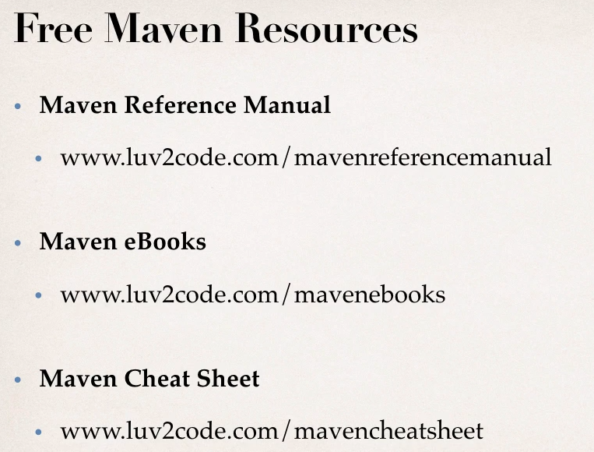

What is Maven

1 Maven is project Management Tool for application

Most popular use is build management and dependencies

Problem Solved by Maven

1 when building java project need additionl jar file ex: spring ,hibernate,commonlogging ,jsonetc

2 one approach is to download the jar files from each project web site

3 Mannually add jar files to build path

My Project Without Maven

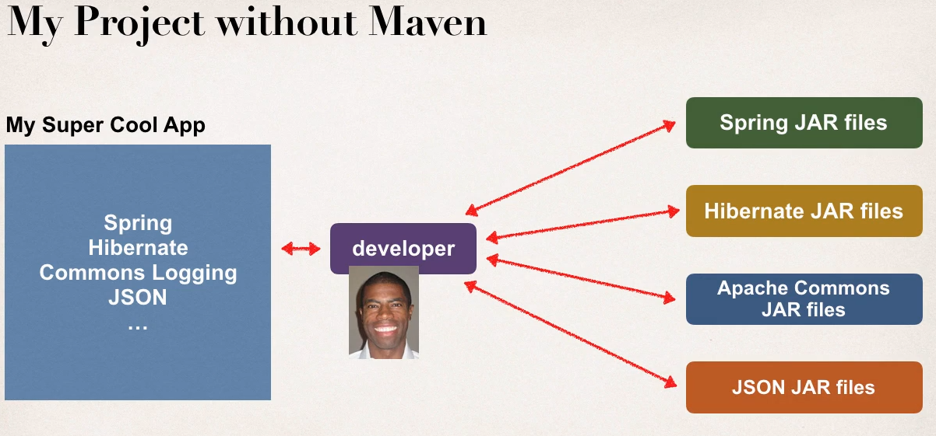

Need to add all jars to build path mannualy

Maven Solution

1 Tell Maven the projects you are working with (dependencies) SPRING , Hibernate

2 MAven will download the jar fiels for you and maven will make it avaiable the jars for compile /run

Maven is like freindly helper / shopper give purchase list he will buy it

My Project With MAven

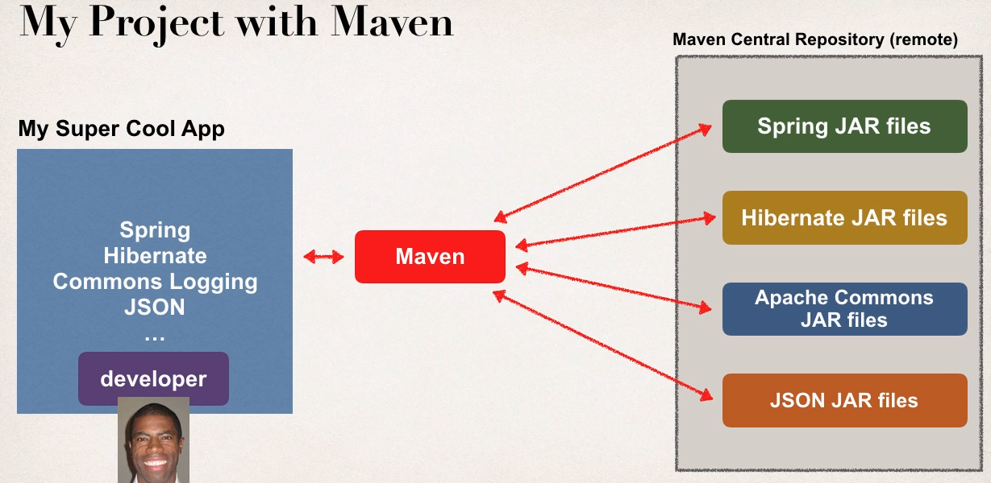

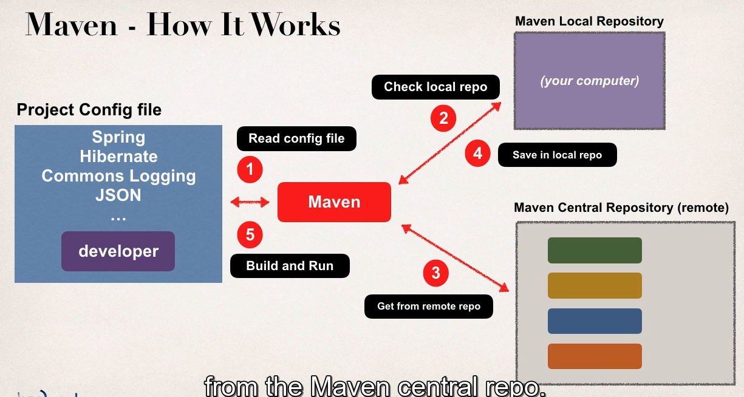

Handling Jar Dependencies

-When MAven retrives project dependcy

1 will download supporting dependices

2 for example spring depend on commons-logging

-MAven will handel this automatically

During build and run MAven will handel calss and build /path

Maven Overview

Standard Directory Structure

-Normal when you join new Project

1 Each dev team dream up thier own directory structure

2 not ideal for new comers and not standrdized

Maven Solve this problem by giving a standard directory Structure

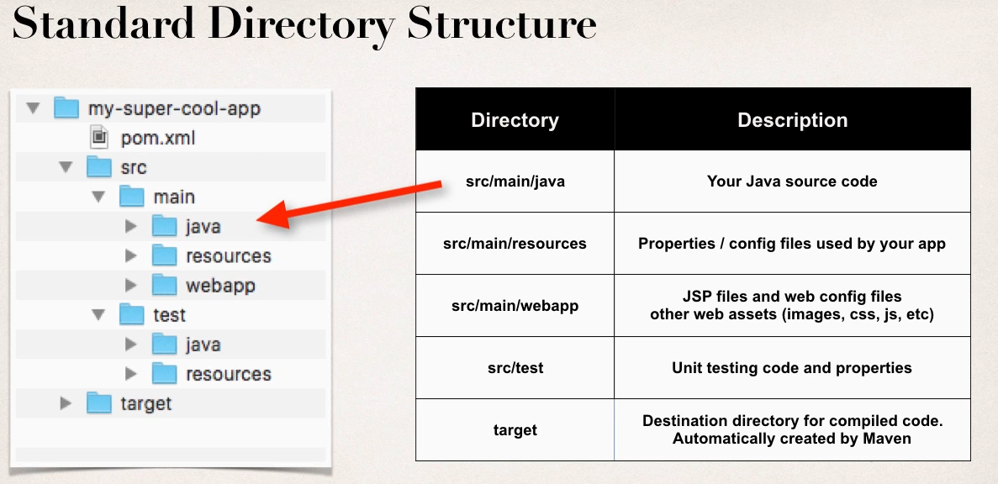

Benefits

- for New members

To find code , properties files, unit test, web files etc

Built in MAven support from lot of IDE

Maven projects are portable easily projects can be shared thotugh IDE

Advantage of MAven

Dependency MAnagement

- jar file be found by MAven

-No missing jars

Buiding and Run Project

-no more build or class path issues

Standard Directory structure

MAven Key Concepts

1 POM File pom.xml : Project Object Module file

2 Project Cordinates : Uniquely idnetifies a project, simlar to GPS coordiante

POM File:

- config file for ut project, basicaly shopping list for Maven

-located in root of MAven project

POM structure

Pom.xml

-project meta data

-dependencies

-plug ins

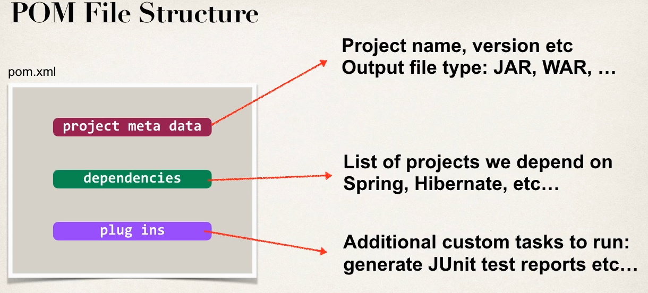

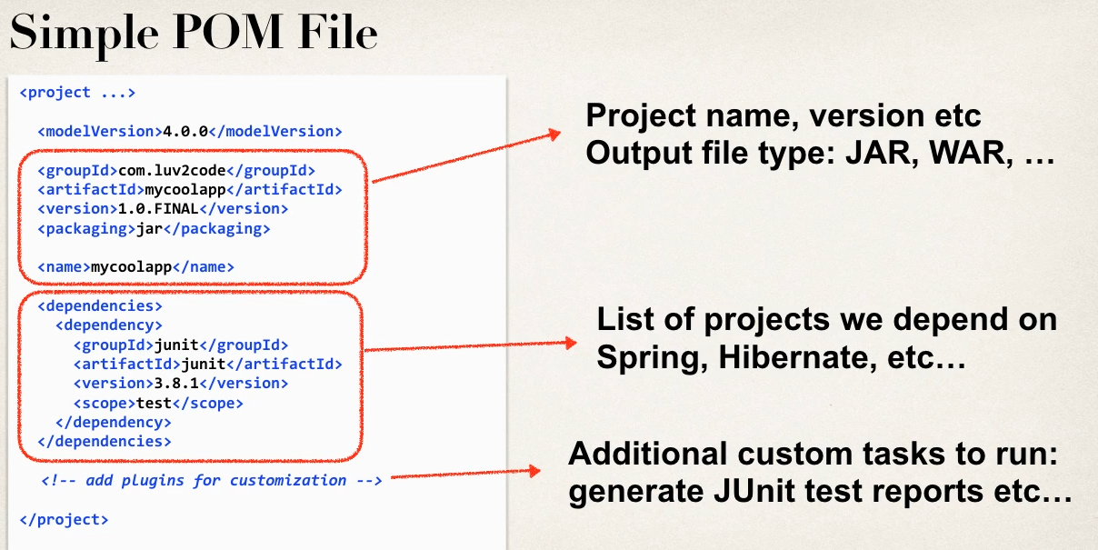

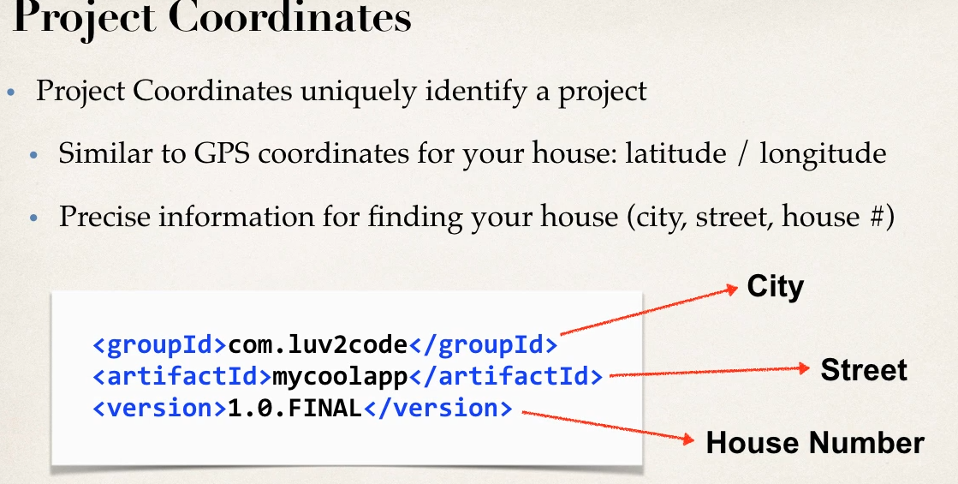

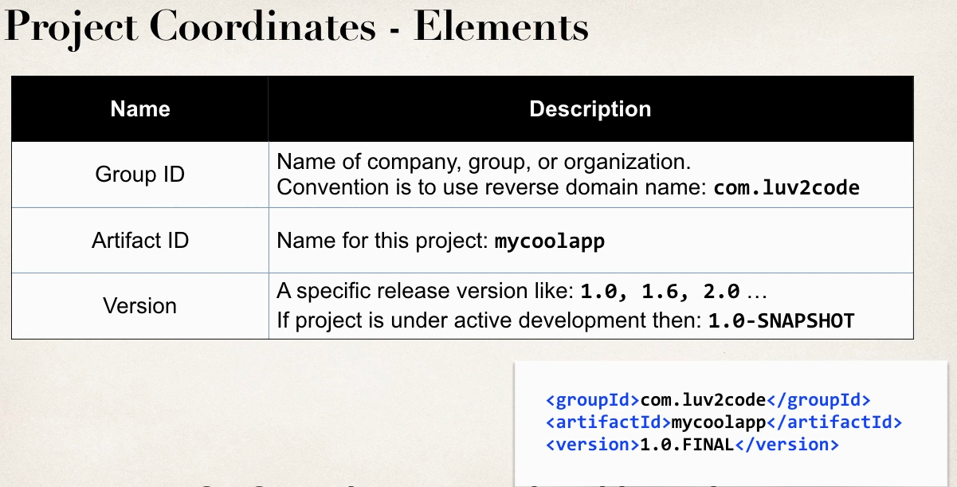

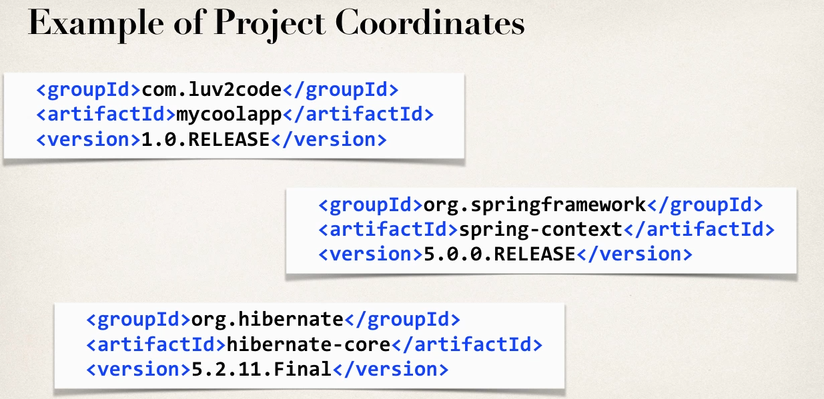

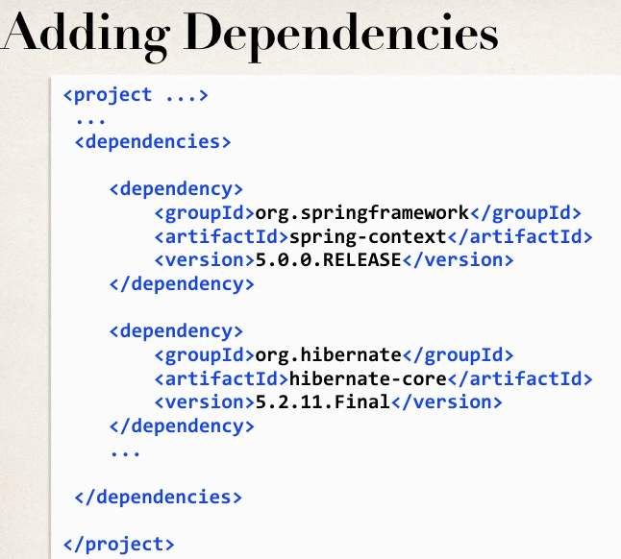

Dependency Cordinates

To add given dependency project we need GAV

1 GroupID,ArtifactID

2 Vesrion Is optional (but include version to avoid repeatable builds)

How to find Dependecny corodinate

1 visit project site

2 maven center repo search.maven.org

3 [www.mvnrepository.com](http://www.mvnrepository.com)

Maven Archetypes

1 Archetypes to create new MAven Projects

2 contain template files for a given MAven Projects

3 Think of its a collection of “starter files ” for a projects

-- java ,web project etc

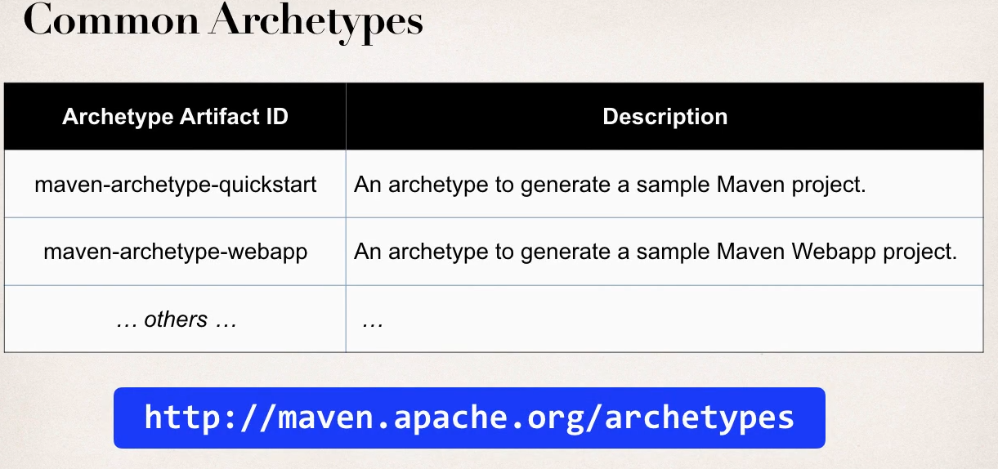

-you can create new projects using MAven Archtypes(starter prjects) from common line with MAven

- From IDE also can created

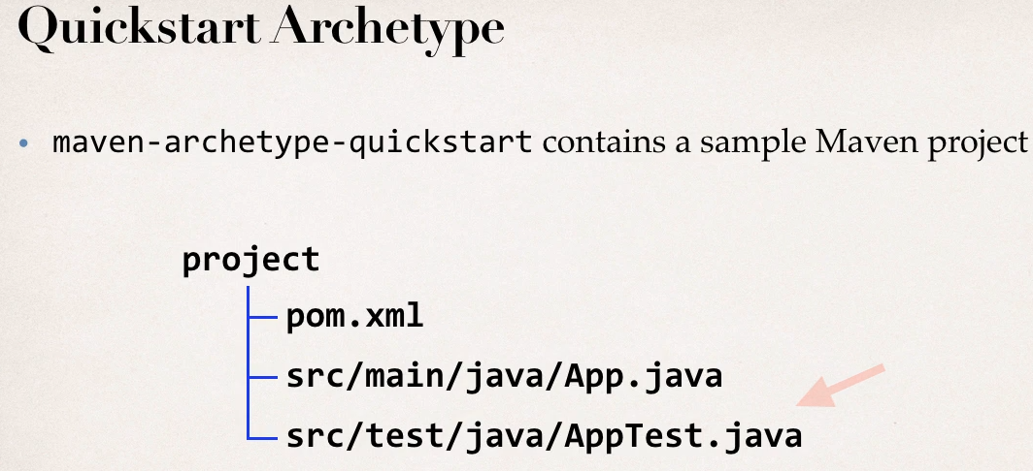

Creating Simple Maven Project

1 Eclipse support for maven

2 Create simple MAven project with Eclipse

3 change JAva VErsion

Latest Eclipse have support for MAven so no need to use m2eclipse plugin

No need install and download Maven sepratley

Can create Maven project ,add dependencies all insdie Eclipse IDE

By creating a Sample quickstart project it will be running in Java 1.5 default so change in pom.xml for java version

Inside property Tag

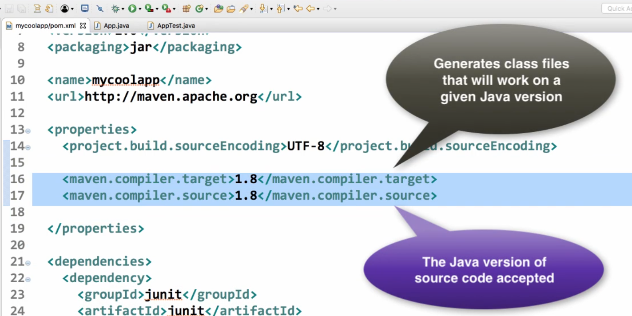

Then Maven from and Update project

For Web Archetypes select web

Need to add servlet Api dependency

Javax.servlet-api 3.1.0

<dependency>

<groupId>javax.servlet</groupId>

<artifactId>javax.servlet-api</artifactId>

<version>3.1.0</version>

</dependency>

Repository Type

1 Local

2 Central

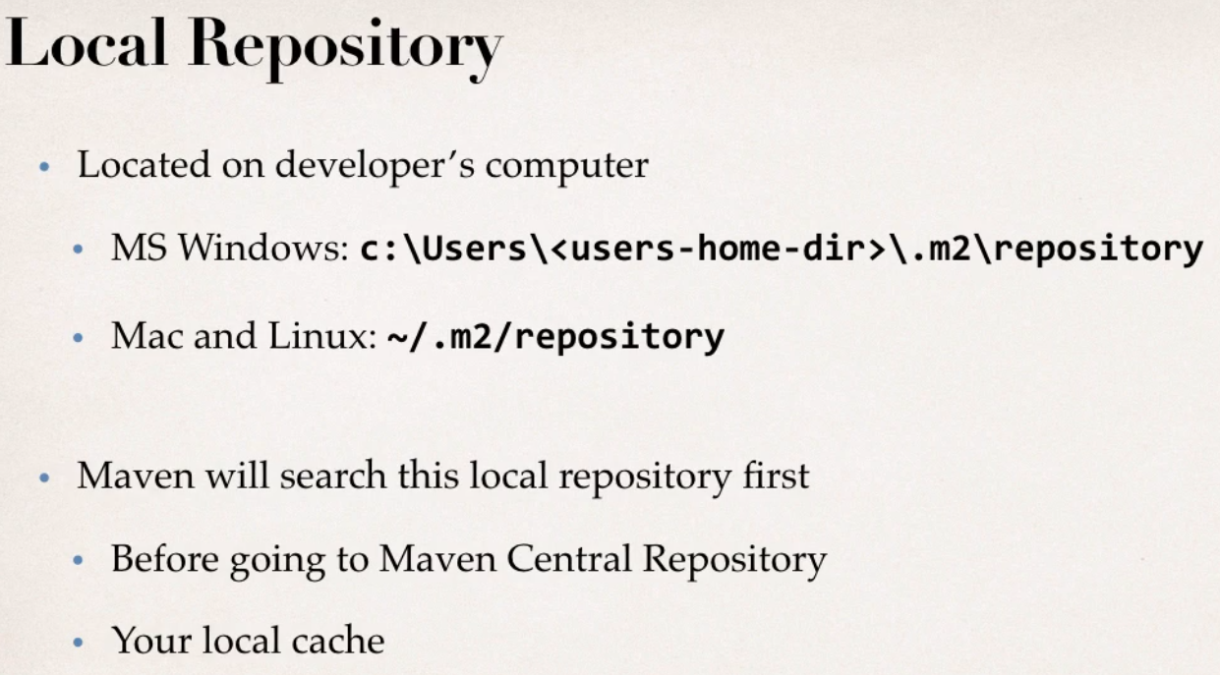

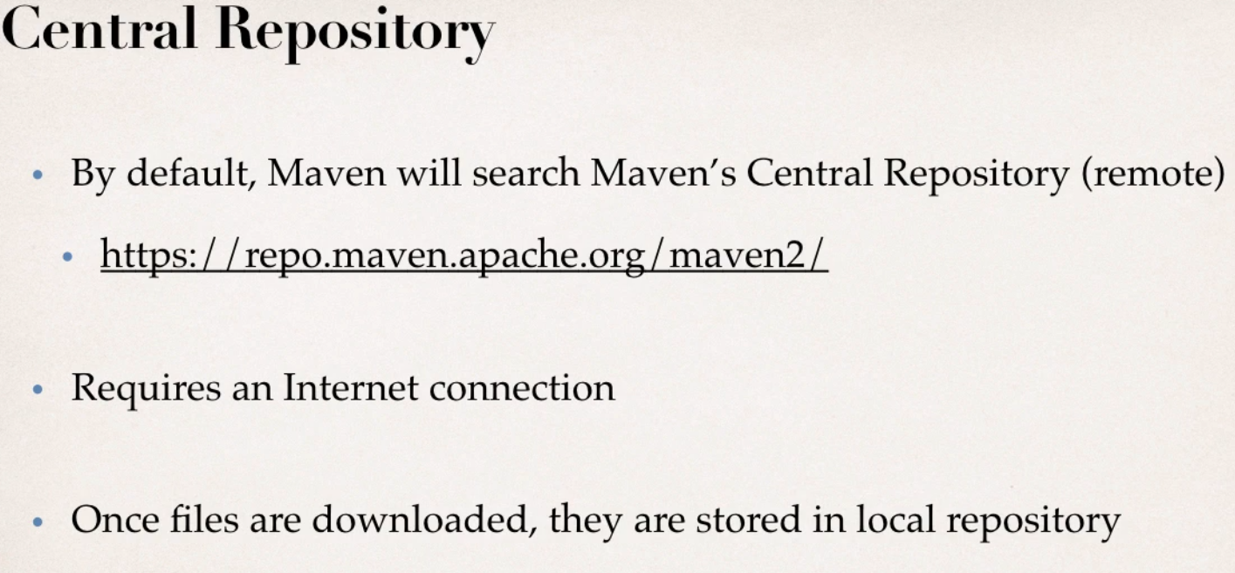

Additional Repository

Chose project not in Maven Central repository

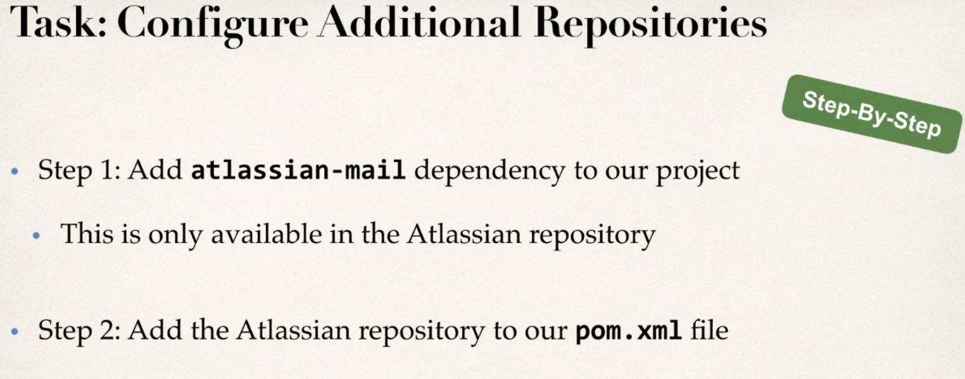

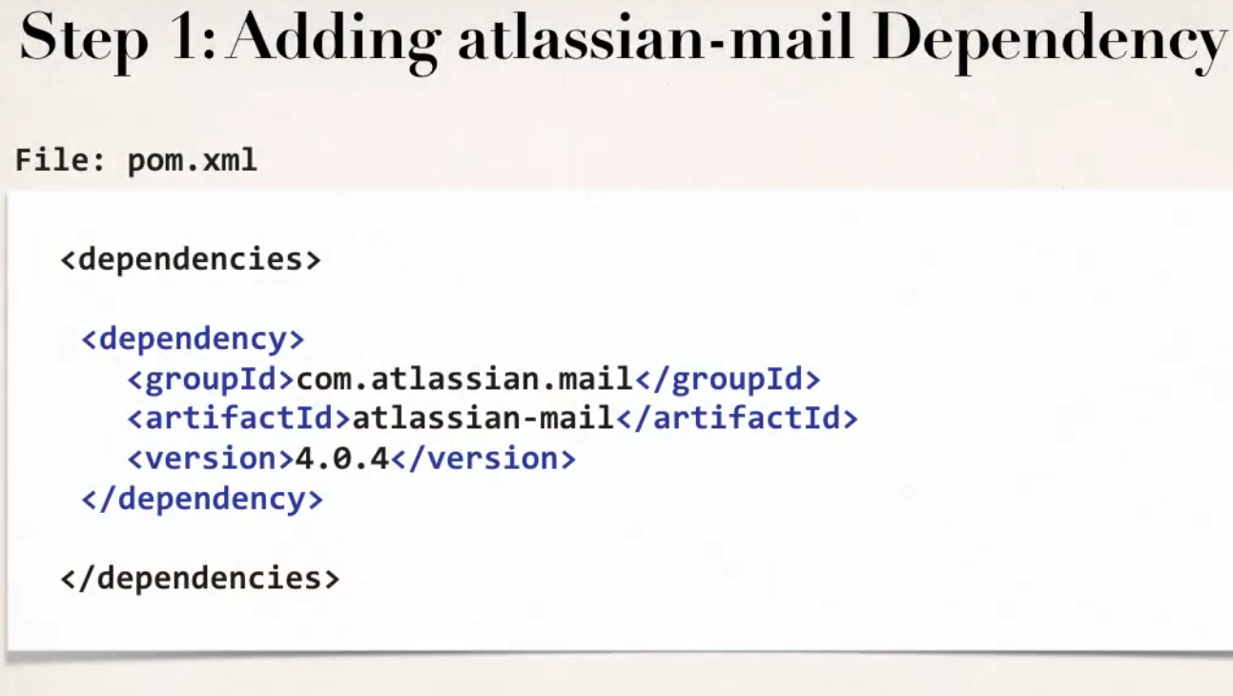

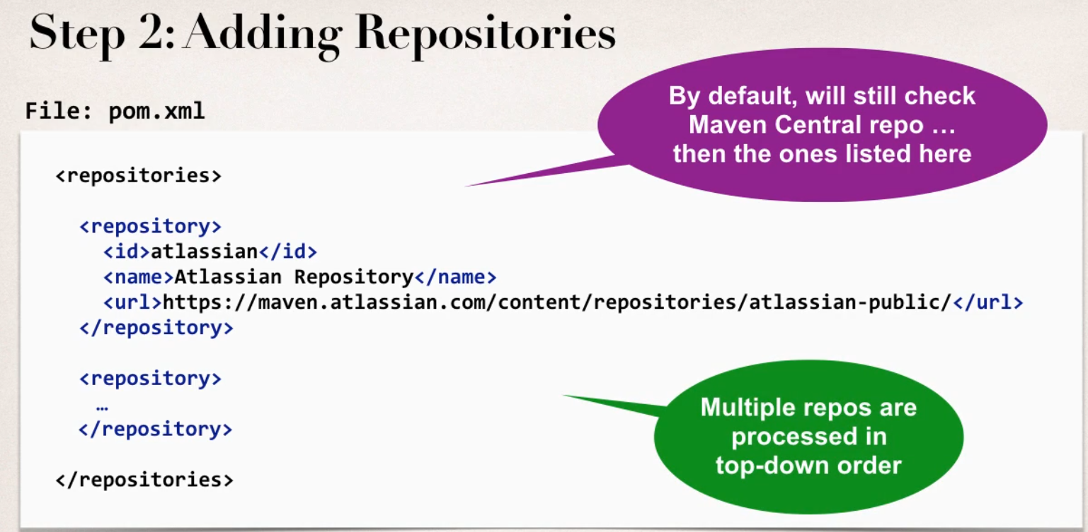

<project xmlns="http://maven.apache.org/POM/4.0.0"

xmlns:xsi="http://www.w3.org/2001/XMLSchema-instance"

xsi:schemaLocation="http://maven.apache.org/POM/4.0.0 http://maven.apache.org/xsd/maven-4.0.0.xsd">

<modelVersion>4.0.0</modelVersion>

<groupId>com.personal.test</groupId>

<artifactId>quickstartapp</artifactId>

<version>0.0.1-SNAPSHOT</version>

<packaging>jar</packaging>

<name>quickstartapp</name>

<url>http://maven.apache.org</url>

<properties>

<project.build.sourceEncoding>UTF-8</project.build.sourceEncoding>

<maven.compiler.target>1.8</maven.compiler.target>

<maven.compiler.source>1.8</maven.compiler.source>

</properties>

<dependencies>

<dependency>

<groupId>junit</groupId>

<artifactId>junit</artifactId>

<version>3.8.1</version>

<scope>test</scope>

</dependency>

<dependency>

<groupId>com.atlassain.mail</groupId>

<artifactId>atlassain-mail</artifactId>

<version>4.0.4</version>

</dependency>

</dependencies>

<repositories>

<repository>

<id>atlassain</id>

<name>Atlassain Repository</name>

<url>https://maven.atlassain.com/content/repositories/atlassain-public</url>

</repository>

</repositories>

</project>

Private Repository

If we want make our repo privae only shared in company thrn privae Repository

- will set up own private repository

- secure wit credentials

- then publish projects in that repo

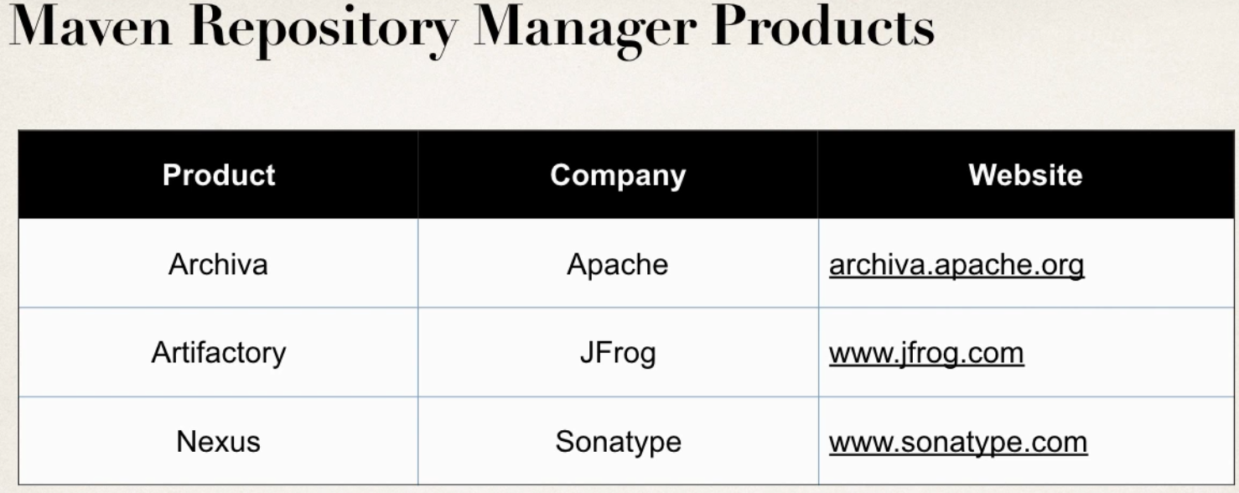

CRM app in MAven dependency move existing code into Web Archtype

If building issues

Aplcaition - Properties- Depolyment Assembly- Add- Java Build path- MAven Depency -Run